

**CS 1632 Software Quality Assurance**

**Deliverable 3: Automated Web Testing**

Member 1 Name: Alex Chlpka

Member 2 Name: Evan Moran

Team Name: Special Sauce

1. **Introduction**

Our division of work was developing the test cases on Selenium together in class with Alex converting those to Junit testing to check for any problems that may occur and fixing them. Evan then found 3 defects and added the tests to reproduce them in the test suite. This report is written by Alex using information that was gathered by Evan.

There weren’t really any huge problems using Selenium other than some conversion to Junit but nothing that wasn’t easily solved with some of the basic knowledge from previous lectures.

1. **Defects**

IDENTIFIER: DEFECT1-FUN-FEED-CAT

SUMMARY: Attempting to feed all 3 cats with 0 food should show that there is a cat fight because 0 cannot be divided among 3 cats, but it does not.

DESCRIPTION: Feeding cats with 0 food does not provide the correct output.

REPRODUCTION STEPS:

* Open a web browser and go to the URL <https://cs1632.appspot.com/feed-a-cat>
* Click on the box next to ‘Number of catnips to feed’ and enter 0
* Click on the ‘Feed’ button

EXPECTED BEHAVIOR: The area next to the ‘Feed’ button should display “Cat fight!”

OBSERVED BEHAVIOR: The area next to the ‘Feed” button displays “Nom, nom, nom.” 

_____________________________________________________________________________________

IDENTIFIER: DEFECT2-FUN-GREET-CAT

SUMMARY: After renting out all three cats, the greet cat page displays the wrong output.

DESCRIPTION: When there are no cats available, going to the greet cat page should have a blank output, but it is not.

REPRODUCTION STEPS:

* Open a web browser and go to the URL <https://cs1632.appspot.com/>
* Click on the ‘Rent-A-Cat’ link
* In the box next to ‘Enter the ID of the cat to rent:’, enter the cat ID 1, then click the ‘Rent’ button
* Repeat the last step for cat ID 2 and 3
* Click on the ‘Greet-A-Cat’ link

EXPECTED BEHAVIOR: The area below the cat list should be blank

OBSERVED BEHAVIOR: The area below the cat list says “Meow!Meow!Meow!”

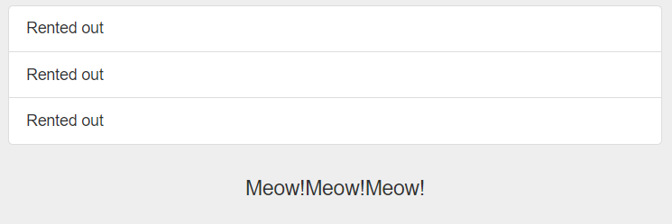

_____________________________________________________________________________________

IDENTIFIER: DEFECT3-FUN-GREET-A-CAT-WITH-NAME

SUMMARY: After renting out Jennyanydots, attempt to greet that cat.

DESCRIPTION: The cat is rented out, so the page to greet the cat at should acknowledge that.

REPRODUCTION STEPS:

* Open a web browser and go to the URL <https://cs1632.appspot.com/>
* Click on the ‘Rent-A-Cat’ link
* In the box next to ‘Enter the ID of the cat to rent:’, enter the cat ID 1, then click the ‘Rent’ button
* Go to the URL <https://cs1632.appspot.com/greet-a-cat/Jennyanydots>

EXPECTED BEHAVIOR: The area below the cat list should say “Jennyanydots is not here.”

OBSERVED BEHAVIOR: The area below the cat list says “Meow! from Jennyanydots.”

